浙江音乐学院2024年专升本招生简章

来源：招生办公室 时间：2024-01-15 编辑：点对点考研

[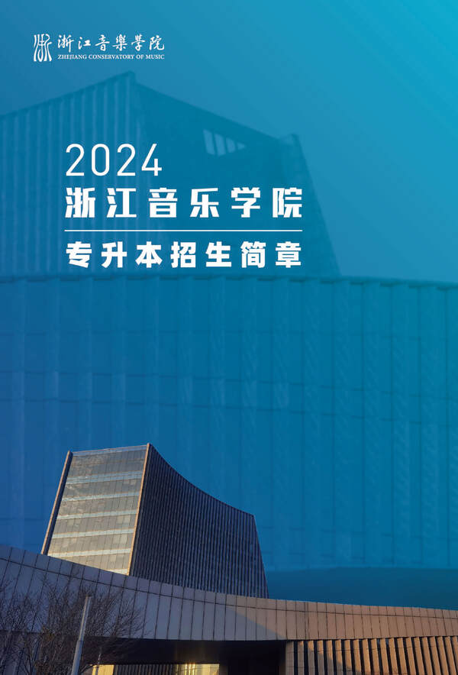](https://www.zjcm.edu.cn/attachment/20240115/a15f6bb5a60ec33aa8f3a3d8915145ee.jpg)

[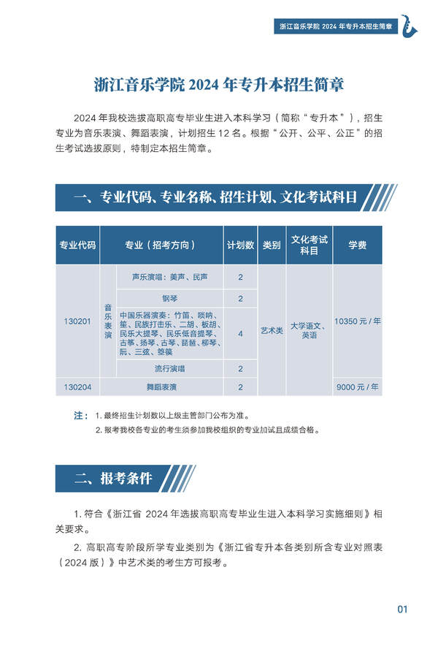](https://www.zjcm.edu.cn/attachment/20240115/e41c5f921e5b1238430acfa13569a29f.jpg)

[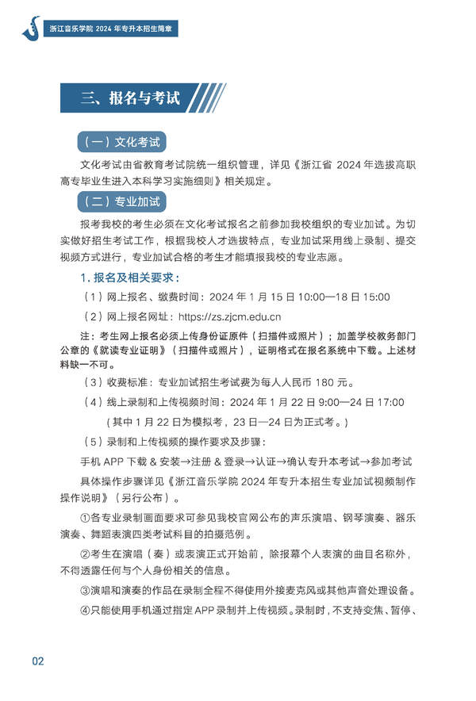](https://www.zjcm.edu.cn/attachment/20240115/0941cf83f3856438eea7860b288d1aff.jpg)

[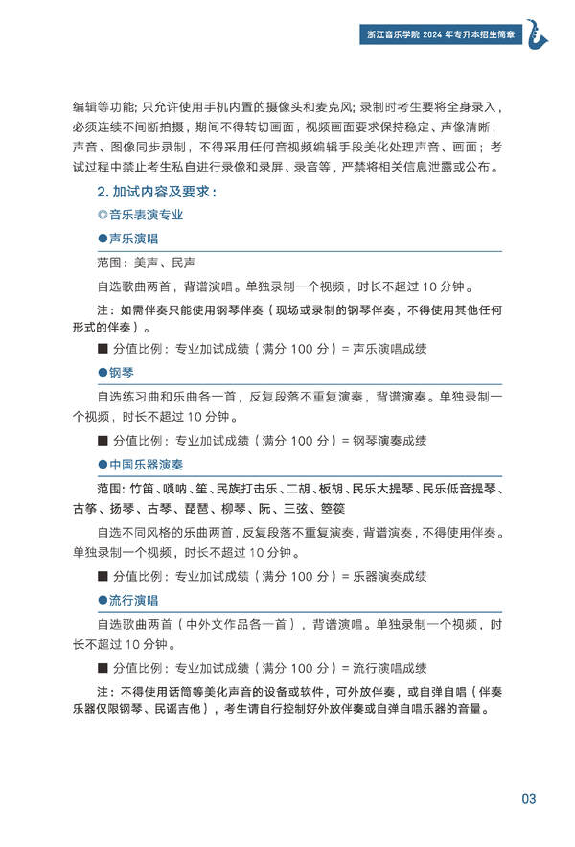](https://www.zjcm.edu.cn/attachment/20240115/0e03fd00d96a331f9eeb9bf37f85c8e6.jpg)

[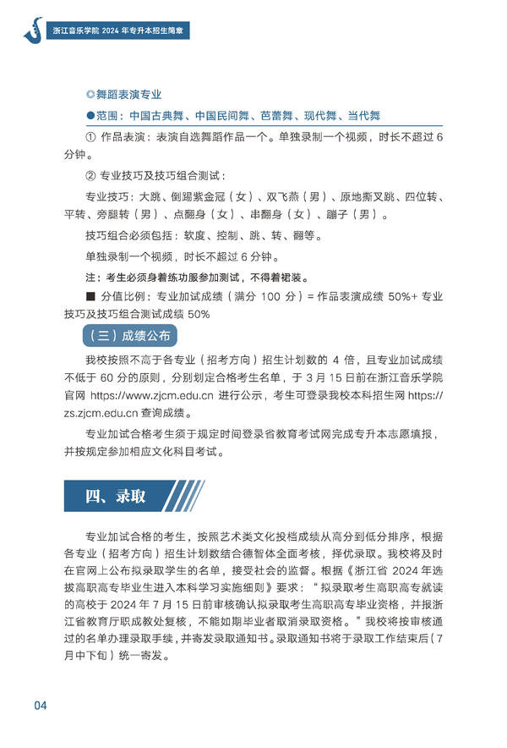](https://www.zjcm.edu.cn/attachment/20240115/5bae94976cb6f85c6b24a0a74fd1f0c1.jpg)

[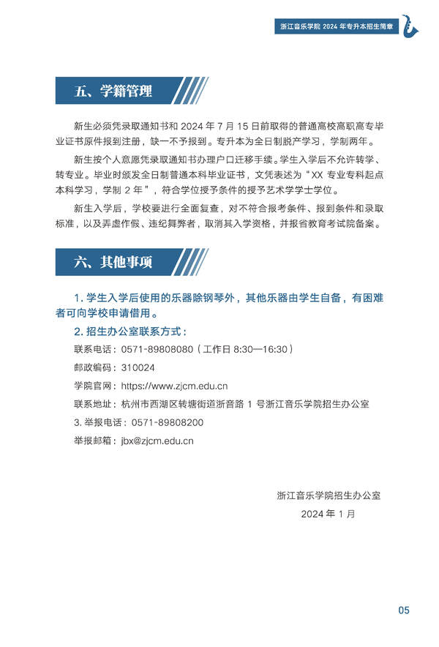](https://www.zjcm.edu.cn/attachment/20240115/72386bc7cf5f0c1a489b1922432e101b.jpg)

[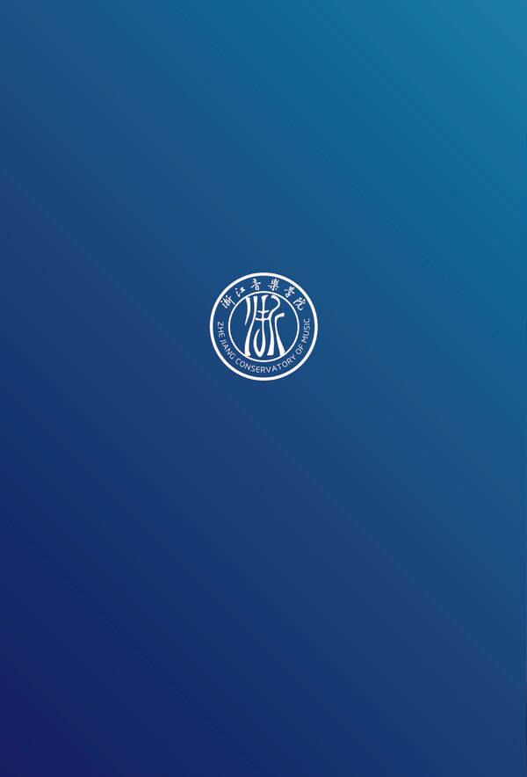](https://www.zjcm.edu.cn/attachment/20240115/23528a0dfd863c35039ef01ddd89840a.jpg)